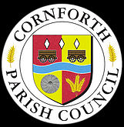

CHRISTMAS / NEW YEAR

2021/22

CLOSING TIMES

Cornforth House will close to the public for Christmas/New Year

From

Saturday 18th December 2021

And

will re-open on

Tuesday 4th January 2022.

For Council business emergency contact details during the closure period will be:

Parish Clerk: Mob: 07899277892

Parish Chairman: Mob: 07724761432

For non-urgent matters please email the Parish Clerk and these will be picked up after the closure period. [clerk@cornforthparishcouncil.org](mailto:clerk@cornforthparishcouncil.org)

The Parish Council wishes everyone a very

AND A 

j0105182